MandibLever: a computational model of jaw biomechanics
Version 4.0

Copyright Mark W. Westneat
Department of Organismal Biology and Anatomy, University of Chicago, Chicago, Illinois, 60637, USA
773-702-2412 mwestneat@uchicago.edu

Introduction
Fish mandibles are relatively simple levers powered during closing by the adductor mandibulae muscles. Similar designs are present in most vertebrates for jaw closing, allowing broad comparison of a basic lever design among many taxa. Adductor muscles for jaw closing pull the mandible around a point of rotation at the jaw joint using a third-class lever mechanism. The software application Mandiblever is an interface for Mac OS X allowing simulation of the mandibular lever model for the jaw of fishes using muscle design and the Hill equation for non-linear length-tension properties of muscle to calculate dynamic power output. The model uses morphometric data on skeletal dimensions and muscle proportions in order to predict behavior and force transmission mediated by lever action. The computer model calculates a range of dynamic parameters of jaw function including muscle force, torque, effective mechanical advantage, jaw velocity, bite duration, bite force, work and power.
Users of Mandiblever might include anyone with the appropriate morphometrics from any vertebrate jaw (excluding many mammals with their muscle slings). The model was created for fishes with an A2 and A3 subdivision of the AM complex that insert directly on the lower jaw, but other jaws should work too.

Using and Citing Mandiblever
MandibLever is free and open access. I can help you get started using it, and I am interested to see new results with it, and can help check for possible errors or bugs that might emerge with new data or applications. So feel free to send me preliminary results so I can double-check for errors in the program (or your data). More active participation on my part in running simulations and interpreting results may be enlisted if collaboration is arranged. If you use it I would appreciate it if you cite it as follows:
MandibLever: a computational model of jaw biomechanics (Westneat, 2003). Version 4.0 released 4/1/2014
Westneat, M. W. 2003. A biomechanical model of muscle force, motion, and power output in the lower jaws of fishes. J. Theor. Biol. 223:269-281

System Requirements:
Any Apple computer, minimal RAM config, OS X version 10.5 and up.

Bugs and Errors Disclaimer: I have tested the software with several examples, including fishes and lizards, and I am pretty confident in its accuracy. However, MandibLever crashes sometimes, and it may contain errors of assumption or calculation, so no guarantees. If it freezes just use the Force Quit function in the Apple menu. From this manual you should be able to do a hand calculation on a simple example to check it yourself. I would appreciate any feedback about inaccuracy, errors, or bugs.

Modifications and bug fixes

MandibLever 3.2 was originally developed for Mac OS 9 and earlier on the PowerPC chip set, in Pascal using CodeWarrior. Kris Urie translated that version into Java using NetBeans. In prior versions, there were a few bugs in computation of the A3 muscle insertion point, and some errors that happened when jaws with unusual dimensions or muscle positions were entered, although the errors impacted the graphics and not the muscle or bite force computations. The code has now been moved to Objective C using the Apple XCode Developer Tools. New features:
- Jaw graphics put both muscles on same jaw image (rather than being separate)
- Animation function is new (could make a video more easily now).
- Bite force is computed at tip of jaw (like before) and also at an interior “molar” point which is adjustable.
- Coordinate data input now available- recommended as it is more accurate than distance metrics.
- A set of several species is loaded up at start so you can play around with some fish heads before you have your own data.

Data Required to Run MandibLever
Sample data: sample data files are appended to the end of this document, and a data set loads automatically upon start-up. You can enter distance data or coordinates.

Coordinate data: In general this is preferred, as a two muscle lever system can be computed based on just 8 coordinates plus the two muscle masses, and measurement error is reduced by measuring each point only once. The app accepts a text file (.txt) with specimen name, 8 sets of coordinates, and 2 muscle masses, separated by spaces.
SpecimenName x1 y1 x2 y2 x3 y3 x4 y4 x5 y5 x6 y6 x7 y7 x8 y8 mass1 mass2
- jaw joint
- tip of tooth or jaw (force output)
- opening inlever: IOP ligament attachment
- central origin of A2 muscle
- insertion of A2 on jaw
- central origin of A3 muscle
- insertion of A3 on jaw
- muscle-tendon junction for A3
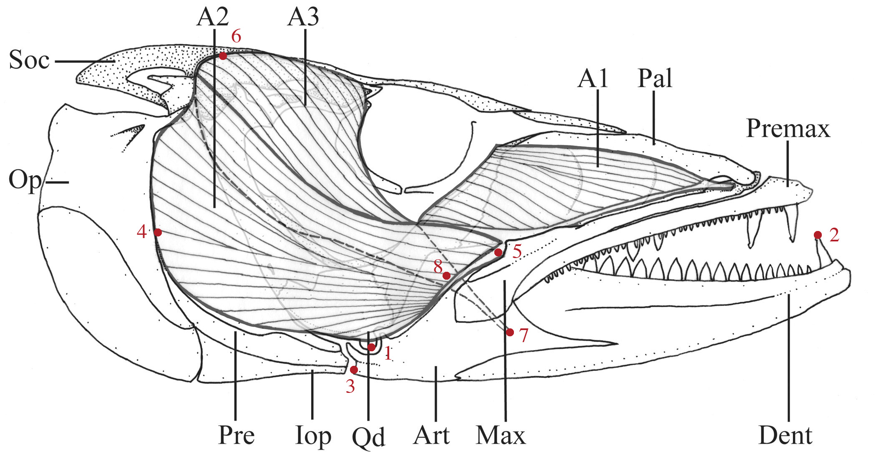

Distance data: distance data involves measuring the specimen with a greater number of measurements, in order to derive the coordinates through trigonometry. Data required to run the program includes 12 morphometric measures and 2 muscle masses (Table 1, Figure 1). All lengths must be in cm and mass in g (the program corrects them automatically to meters and kg for work and power calcs). If only one muscle is to be examined, data for the other can be dummy variables (or just a duplicate). There are three major cranial muscles on each side of the head that control jaw closing in most bony fishes (Fig. 1). These are the A1, A2, and A3 subdivisions of the adductor mandibulae muscle. The A1 subdivision usually attaches to the maxilla, a part of the upper jaw protrusion mechanism. Contraction of the A1 pulls the maxilla posteriorly, retracting the upper jaw and indirectly transmitting force to the mandible through a linkage mechanism (Westneat, 1994). The A1 component is not modeled as part of the lower jaw mechanism here in order to focus on the function of the major jaw closers, A2 and A3. The A2 and A3 components attach directly to the mandible at different insertion points and are modeled as the force generators for mandibular closing. Highly pennate muscles have higher effective cross-sectional area and lower velocity than fusiform muscles, so the model includes a user option for simulation of the effects of pennation.

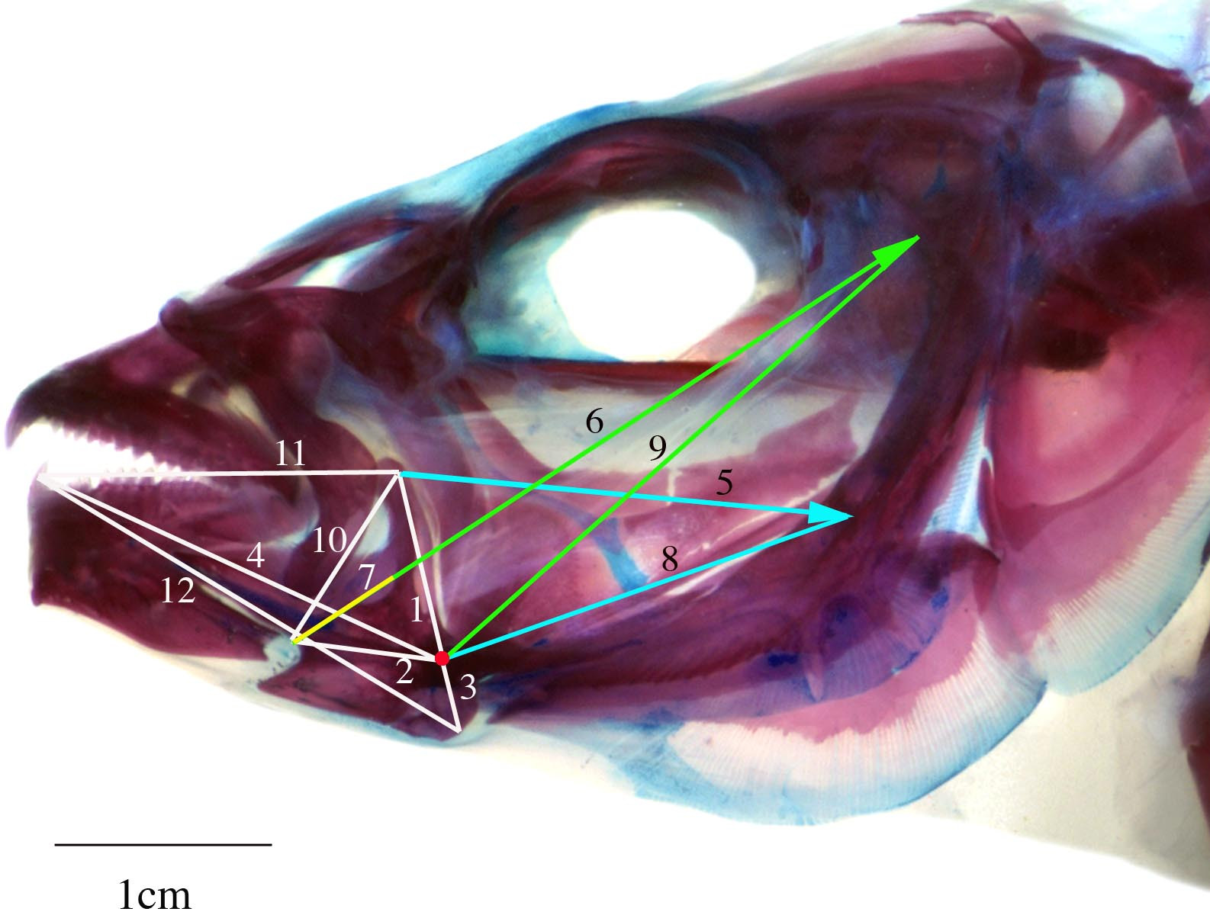

Figure 1. Morphometric distances used in MandibLever. 1, 2, and 3 are inlever lengths of A2, A3, and jaw opening. 4 is the outlever. 5 is A2 length, 6 is A3 length, and 7 is the A3 tendon length. 8 and 9 are distances from muscle origin to jaw joint. 10 is the distance between A2 and A3 insertion points. 11 is the jaw top, from A2 insertion to tooth tip, and 12 is the jaw bottom length, from tip of opening inlever to tip of jaw.

Figure 2. Diagram of adductor muscles A1 and A2 and their actions on the mandible.

Table 1. Morphometric data used in the mandibular lever model. All lengths must be in cm (the program corrects them automatically to meters for work and power calcs).

1. Inlever for A2 division of adductor mandibulae muscle, from quadrate-articular joint to insertion of A2 muscle on ascending process of articular.
2. Inlever for A3 division of adductor mandibulae muscle, from quadrate-articular joint to insertion of A3 muscle on medial face of mandible.
3. Inlever for jaw opening, from quadrate-articular joint to insertion of interoperculomandibular ligament on posteroventral margin of articular
4. Outlever of lower jaw, from quadrate-articular joint to anterior-most tip of dentary or tip of anteriormost canine tooth.
5. A2 muscle length, from origin on ventral margin of preopercle to insertion on ascending process of articular.
6. A3 muscle length, from origin on preopercle and hyomandibula to insertion on ascending process of articular (includes A3 tendon length- green plus yellow line).
7. A3 tendon length, from origin on tapering end of A3 muscle to insertion on ascending process of articular (yellow line).
8. Distance from A2 origin to quadrate-articular joint.
9. Distance from A3 origin to quadrate-articular joint.
10. Distance from A2 insertion to A3 insertion.
11. Mandible dorsal length: tip of coronoid process of articular to anterior jaw tip.
12. Mandible ventral length: posteroventral margin of articular to anterior jaw tip.
13. A2 muscle mass.
14. A3 muscle mass.

Mandiblever calculations:
Average muscle cross-sectional area (cm²) is computed as mass (g) times the cos of the pennation angle divided by length times muscle density, assuming that muscle density is 1.05 g per cm³ (McMahon, 1984). CSA= m*cosα/ρ
Additional parameters of the model that are user-specified include maximal isometric force per unit area of muscle (F_{max}), estimated maximum contraction velocity of muscle (V_{max}), and a set of muscle length, tension and force properties to be simulated at each stage of muscle contraction. The software accepts user-specified values of V_{max} and F_{max}, and the range of V/V_{max} and F/F_{max} during muscle contraction. Maximum shortening velocities of vertebrate muscle (V_{max}, the peak unloaded contraction speed) range from 3-5 muscle lengths/sec in fish red muscle (Rome et al., 1992), to as high as 8-10 lengths/sec in fast white muscle of fishes (James et al., 1998) or frogs (Peplowski & Marsh, 1997). The model uses a default is 10 L/s, assuming that jaw muscles are fast, white fibers. Maximal isometric stress in muscle varies among vertebrate muscles in different body regions, but values for fish muscle range from about 100-200 kN/m² (kPa) in red fibers (Rome et al., 1992) or white fibers (James et al, 1998) involved in locomotion. A value of 200 kPa is the default used by MandibLever.
Muscles exert maximal force in the central portion of their working range, and less force when either stretched or contracted. Muscles shorten with greatest speed when stretched, and velocity drops as muscles reach their force peaks (Josephson, 1999). Muscles often attain their F_{max} values during real behaviors, though V/V_{max} values for fish locomotor muscle are often restricted to be less than 0.5 (Rome et al., 1992) unless they are under low load. Mandiblever assumes that the jaw muscle is at its peak force range when the jaw is closed to enable a strong bite. The fully stretched muscle is therefore simulated to contract with a high V/V_{ma} and low F/F_{max}. In other words, after opening the jaw, the program starts to close the jaw with high velocity and low force, and by the time its closed it is operating at low velocity and high force.
The nonlinear dynamic relationship between force and muscle velocity is characterized by the Hill equation (Hill, 1938): F = (1-V)/(1+V/k) (1)
where k is a constant, usually about 0.25 (McMahon, 1984). Mandiblever uses 0.25 for all calculations. This equation is used to determine force and velocity relationships for all simulations. Default values for simulations are a minimum V/V_{max} of 0.05, and peak V/Vmax values of 0.8 (these can all be set to alternative values in the software).
Initial opening of the mandible is simulated by performing a total rotation angle of 30°. The model calculates angular velocity of opening and the total gape achieved. Other parameters of the jaw system are also computed, including the mechanical advantage (inlever/outlever) and velocity ratio (outlever/inlever) for each muscle.
The model performs the following series of calculations for each muscle:
1. Planar geometry and Cartesian coordinates of all musculoskeletal elements for the closed and open positions.
2. Stretched lengths of A2 and A3 in open position.
3. Percent muscle contraction required to close lower jaw.
4. Muscle contraction required for jaw closing divided into 20 simulation bins (number of simulation bins can be user-specified).
5. Range of V/V_{max} and F/F_{max} divided into 20 simulation bins.
6. For each contraction bin, summed until jaw is closed, the model computes jaw rotation, time duration for contraction, tip motion, velocity, force, torque, work, power, and effective mechanical advantage.

Computations for each successive bin of muscle contraction and jaw closing are performed by the following equations:

Contraction duration (ms), t = %contraction / (V_{max}* V/V_{max}) (2)
where %contraction is the percentage muscle contraction simulated in that bin, and V/V_{max} changes during jaw closing. Total closing duration is the sum of all duration bins.

Angular velocity (°/ms), U_{ang} = r/t (3)
where r is the jaw rotation angle computed from coordinates of the jaw joint and tip.

Gape velocity (cm/ms), U_{g} = d/t (4)
where d is the jaw tip distance traveled computed from coordinates of the jaw joint and tip.

Acting muscle force (N), F_{act} = F_{max} * F/F_{max} (5)
where F/F_{max} is low at the start of jaw closing and high at the end of jaw closing.

Torque (Nm), T = F_{act} * sin(α)* L_{i} (6)
where α is the angle of insertion of muscle onto the inlever at each position during closing (Fig. 4) and Li is inlever moment arm.

Force output at jaw tip (N), F_{out} = F_{act} * sin(α) * MA (7)
where MA is the mechanical advantage of the lever.

Effective mechanical advantage, EMA = F_{out} /F_{act} (8)
(a more direct way is that EMA = sin(α) * MA)
a measure of the amount of effective force per unit muscle force (after Biewener, 1989).

Work (J), W = F_{act} * c (9)
where c is the contraction distance of the muscle where it inserts on the jaw.

Power (W), P = W/t (10)
which is calculated as both Watts and is expressed as watts/kg by dividing by muscle mass.

MandibLever draws the mechanical design in open and closed positions as a visual heuristic of data reliability. The overall simulation results of jaw rotation, velocity, muscle contraction, force, torque, work, and power are output to the user-interface to provide the user an interactive means of manipulating the input variables of both morphometrics and muscle contractile properties.

MandibLever Interface:
A screen grab of the MandibLever interface is shown below. There are no menus (except Quit), just buttons. You can play around with the sample data loaded automatically. To run your own data, the first thing you must do is open a data file. Example data files are included in the package. Assuming no file errors, when you open a file the morphometric data are shown in the column to the left, and default simulation parameters are shown in the right upper column. Click NextJaw and PrevJaw to toggle back and forth between data sets. Below the drawing you can move it around or Magnify or Reduce it in size, if it is not quite fitting in the window.
You can click in the Sim Parameters boxes and modify your Sim Parameters. For example, you can change the value of muscle Vmax from 10 l/s to something else (hit return to log in the new value). F/Fmax is dependent on V/Vmax (according to the Hill equation), so when you change V/Vmax the F/Fmax value changes. You can also enter a muscle fiber pennation angle for either or both of your muscles. The initial lower jaw opening angle can be changed, and you can change the number of bins that the muscle contraction is divided into. Jaw closing is divided into small separate bins of motion, by default 20 sequential stages of muscle contraction and jaw closing. At each iteration the velocity gets slower and the force gets stronger, like a good muscle should.

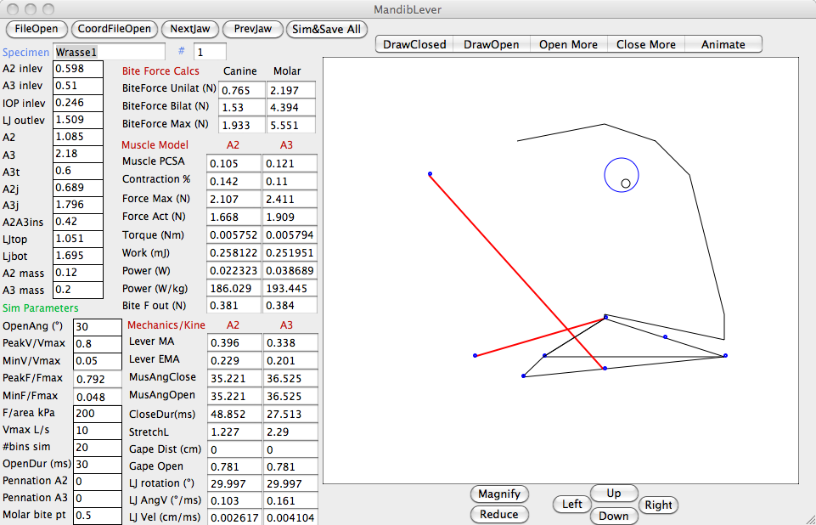

Simulations:
After successfully loading your data file, you can run various simulations by changing the Sim Parameters, and then clicking between specimens or hitting the DrawClosed or DrawOpen buttons. All simulations begin by rotating the jaw open, and calculating a few jaw opening variables like gape distance, angular velocity, the mechanical advantage and velocity ratio of the opening lever, and how much each of the muscles are stretched. In addition, the coordinates of closed and open jaws are calculated for graphic illustration. You can toggle the jaw More or Less Open, and Animate the mechanism.

All of these calculate a straight Hill equation muscle contraction for both muscles, provide graphical output of how the jaw moved, and shows the Results of both Muscle Physiology and Kinematics on the screen. Nothing is saved to a file- these are ways to run your data and see what happens. You can view the force, torque, work and power (and force work and power out) for both muscles to see if it all makes sense.

Sim&SaveAll This routine simulates the whole jaw opening and closing event using the Hill equation for all the fish in the data set and outputs the results to data files. Four files are saved to your Documents Folder: *OpenSum.txt, *CloseSum.txt, *A2sim.txt and *A3sim.txt. Open and Close are summary files of the main variables like mean speed, bite force, muscle work and power for all the specimens. The details of A2 and A3 mechanics are written to the A2 and A3 files, with the detailed results of all iterations of bins. So for the default of 20 bins, there are 20 rows of data for each specimen, starting from jaw all the way open to jaw closed. These are text files, so take to excel and parse them using space delimited TextToTable functions. These files are full of stuff you probably don’t need, but you can make interesting plots of bite force versus jaw closing angle, or time series of force, work and power. You can also see how dynamic the effective mechanical advantage is due to changing angle of insertion of the muscles during jaw closing. Oh- the possibilities are endless!

App Results Tables: Results shown on the interface tables and in the text output files are the same. The results interface onscreen for most variables shows the mean value over the jaw closing cycle (for a few it shows the final value at the end of jaw closing).
Bite Force- most people are interested in bite force. MandibLever computes the portion of bite force due to two muscles- this may or may not be close to the full bite force capacity of an animal. The bite force unilaterally and bilaterally are computed, both with the Hill Equation and using a static maximum value. Also, an interior “molar” bite point is provided, that can be moved forward and backward under SimParameters (vary between 0 at the tip and 1 at the jaw joint). To change bite point, type a number 0-1 in the box and hit return, after you open or close the bite point will move and all molar calcs are in reference to that bite point.
Muscle csArea- Mean cross-sectional area of the muscle, accounting for mass, length, density, and angle of pennation (if any).
Muscle Cont%- Percent muscle has to contract to get jaw back to closed position (=amount stretched during opening).
Force max (N)- Maximal possible contraction force in Newtons, depending on F/area parameter.
Force acting (N)- Mean actual muscle force being exerted on the jaw (changes each iteration of bins).
Torque (Nm)- Mean torque (force * moment arm) on lower jaw for jaw closing (changes each iteration of bins).
Work (J)- Mean work over cycle- Acting force times distance muscle insertion point moves. (changes each iteration of bins).
Power (W)- Mean power, rate of work over cycle. (changes each iteration of bins).
Power (W/kg)- Mean muscle mass specific power. (changes each iteration of bins).
Lever MA- mechanical advantage=inlever/outlever- the classic, nondynamic estimate of force transmission through a lever.
Lever EMA- actual mechanical advantage determined by dynamic, changing angle of muscle insertion.
Velocity ratio- inverse of MA.
Muscle Ang closed and Open. Angle of muscle insertion onto the inlever, shown for start and finish. (changes each iteration of bins).
CloseDur- amount of time it takes for muscle to close jaw under sim conditions.
StretchedL- stretched length of the muscle after jaw opening.
GapeClosed. Distance traveled by jaw tip during jaw closing (should equal gape during opening).
AngV Out- Mean angular velocity of jaw rotation during closing (changes each iteration of bins).
Tip V Out- Mean jaw tip velocity during closing (changes each iteration of bins).

Sample distance data file, this is the default file that is loaded up in the app., and provided in the package. To use it or edit it, save it in text format with spaces between data, a single return between specimens and no returns at end.

Wrasse1 0.598 0.510 0.246 1.509 1.085 2.180 0.60 0.689 1.796 0.420 1.051 1.695 0.12 0.2
Wrasse2 7 5.10 2.8 20 10.85 18.80 6.0 7.89 17.96 4.20 15.51 18.95 1.2 2
Piranha 2.386 2.386 0.903 4.842 5.603 7.258 3.095 6.381 6.939 0.601 4.631 4.996 18.6 3.2
RedSnapper 0.27 0.37 0.19 1.05 0.64 1.21 0.34 0.62 1.1 0.3 0.96 1.22 0.0026 0.005
RoundGoby 0.17 0.157 0.075 0.635 0.687 0.976 0.115 0.693 0.908 0.094 0.546 0.643 0.0134 0.0212

Sample coordinate data file, this text file is also provided in the package, with the format of specimen name, 8 sets of x-y coordinates, and 2 muscle masses it in text format with spaces between data, a single return between specimens and no returns at end.

Testdata1 4.435 2.565 9.608 2.500 3.935 1.913 2.609 2.565 6.282 3.652 0.370 6.913 6.304 2.543 5.587 3.000 0.12 0.2
Testdata2 9.130 5.043 31.957 4.565 9.130 3.783 5.043 5.435 12.565 7.739 3.609 14.870 12.652 5.652 11.609 6.609 1.2 1.8
Testdata3 4.543 2.543 10.630 2.522 4.369 1.500 2.543 2.522 5.674 4.413 3.087 8.043 7.043 2.848 6.261 3.456 3.9 6.4
Testdata4 9.043 5.087 19.304 5 9.130 3.522 3.870 6.870 12.565 7.130 9.174 17.739 13.652 5.739 13.043 6.913 6.8 8.9

Acknowledgments
Thanks to many colleagues, students and collaborators over the years for their discussion of feeding mechanisms, computational models, and comments on the model. This project was supported by the National Science Foundation.

Relevant Literature
Altringham, J. D. & Johnston, I. A. (1982). The pCa-tension and force-velocity characteristics of skinned fibers isolated from fish fast and slow muscles. J. Physiol. Lond. 333, 421-449.
Biewener, A. A. (1989). Scaling body support in mammals limb posture and muscle mechanics. Science 245, 45-48.
Case, J. E., Westneat, M. W. and C. D. Marshall. (2008). Feeding biomechanics of juvenile red snapper (Lutjanus campechanus) from the northwestern Gulf of Mexico. J. Exp. Biol. 211, 3826-3835.
Grubich, J. R., Rice, A. N., and M. W. Westneat. (2008). Functional morphology of bite mechanics in the great barracuda (Sphyraena barracuda). Zoology 111, 16-29.
Hill, A. V. (1938). The heat of shortening and the dynamic constants of muscle. Proc. Roy. Soc. B. 141, 104-117.
James, R. S., Cole, N. J., Davies, M. L. F., & Johnston, I. A. (1998). Scaling of intrinsic contractile properties and myofibrillar protein composition of fast muscle in the fish Myoxocephalus scorpius L. J. Exp. Biol. 201, 901-912.
James, R. S., & Johnston, I. A. (1998). Scaling of muscle performance during escape responses in the fish Myoxocephalus scorpius L. J. Exp. Biol. 201, 913-923.
Josephson, R. K. (1999). Dissecting muscle power output. J. Exp. Biol. 202, 3369-3375.
Lutz G. J. & Rome L. C. (1994). Built for jumping: the design of the frog muscular system. Science 263, 370-372.
Maie, T., Schoenfuss, H. L. and R. W. Blob. (2009). Jaw lever analysis of Hawaiian gobioid stream fishes: A simulation study of morphological diversity and functional performance. J. Morphol. 270, 976-983.
McMahon, T. A. (1984). Muscles, Reflexes, and Locomotion. Princeton University Press.
Peplowski, M. M. & Marsh, R. L. (1997). Work and power output in the hindlimb muscles of cuban tree frogs Osteopilus septentrionalis during jumping. J. Exp. Biol. 200, 2861-2870.
Westneat, M. W. (1990). Feeding mechanics of teleost fishes (Labridae): a test of four-bar linkage models. J. Morph. 205, 269-295.
Westneat, M. W. (1994). Transmission of force and velocity in the feeding mechanisms of labrid fishes. Zoomorphology 114,103-118.
Westneat, M. W. (1995). Feeding, function, and phylogeny: analysis of historical biomechanics in labrid fishes using comparative methods. Syst. Biol. 44, 361-383.

